# **Static Analysis Lab**

Grand Canyon University - College of Engineering and Technology

CYB-320 Malware Analysis

Dr. Michael Varnadore

Liela Pressley

09/08/2024

# **Static Analysis Lab**

# *Lab Questions:*

1. **Which files showed signs of being packed or obfuscated? Explain your rationale.**
   1. Lab 01 was compressed with the Microsoft Visual C DLL packer but the files were not obfuscated as the sections were clearly presented.
   2. Lab 02- showed signs of being packed as seen in the PEiD analysis it showed that it was packed with the UPX version 0.86.6 which is a popular packing program and is easy to use for unpacking. In addition, there are only 3 sections listed and each section has the title “UPX” with the number 0,1,2 which hides the real name and there should be more than 3 sections which hints that the file is obfuscated. In addition, in imports, LoadLibrary is being used which is an indicator that the file could be static linking to the DLL allowing the program to access any function in the library within the system (and not be able to tell which functions are being linked to by the program).
   3. Lab 03- showed signs of being obfuscated as it has a packer: FSG and the section names are only one letter: ‘t’, ‘ta’, and ‘a’ which hides the real section name and prevents us from easily identifying the role of that file and what code it could contain. The lack of having a decent amount of functions listed also makes this suspicious. In addition, LoadLibrary is being used which is an indicator that the file could be static linking to the DLL allowing the program to access any function in the library within the system (and not be able to tell which functions are being linked to by the program).
   4. Lab04 imported LoadLibrary which is an indicator that the file could be static linking to the DLL allowing the program to access any function in the library within the system (and not be able to tell which functions are being linked to by the program). But it does have a decent amount of functions listed in the imported listed.
   5. Rationale is represented with a red box within the provided screenshots.
2. **Which files showed signs of imports and what functionality may they provide? Explain your rationale.**
   1. Lab01 had imports from KERNE32 and MSVCRT; KERNEL32 provided functionality to create, copy, find/close, findfirst, find next, give a map view or unmap view of files and to create a file map. MSVCRT provides internal used functions such as p commode which specifies when critical data is written to disk, fmode which defaults file translation mode for file I/O operations and more.
   2. Lab02 has imports from KERNEL32, ADVAPI342, MSVCRT and WININET. ADVAPI342 is a API Services Library which provides advanced functionality services to the kernel such as windows registry, restart/shutting down, starting/stopping, and managing user accounts. MSVCRT is s compiler for Visual C++ programs and WININET is functions for windows internet and this file specifically imported the InternetOpen function which initializes an application's use of the WinINet functions.
   3. Lab03 has imports from KERNEL32 with the two functions: GetProcAddress (which Retrieves the address of an exported function or variable from the DLL) and LoadLibraryA (which loads a module to a specific location)
   4. Lab04 has many functions imported from KERNEL32, ADVAPI32, and MSVCRT. from creating a file to loading a module to internal functions such as exit, pfmode and more.
   5. Signs of imports is indicated with a pink box
3. **Are any of the files showing network activity? Describe the activity.**
   1. Lab02- Showed signs of network activity such as http GET requests to sectigo.com and dns resolutions to query.prod.cms.rt.microsoft.com and microsoft.com and more. IP traffic was detected mainly using TCP protocols. The main pattern domains included schemas.microsoft.com and malwareanalysisbook.com
   2. Lab03 showed signs of network activity specifically http GET requests to malwareanalysisbook, bingfavicon, and apps.identrust.com. Along with DNS resolutions to ajax.aspentcdn.com with azureedge.net sites and TCP and UDP protocols being the main protocols detected in IP traffic.
   3. Lab01 and Lab04- showed signs of network activity such as HTTP GET requests to the practicalmalwareanalysis executable and msftncsicom txt and DNS resolutions that include the practicalmalwareanalysis website along with microsoft.com, msftnci.com, query.prod.cms.rt.microsoft.com,etc. There is IP traffic detected mainly using TCP and UDP protocols.
   4. Indications of network activity are shown with a blue box.
4. **What additional information can be compiled from the analysis of the scan?**
   1. There is a plethora of information that can be gathered from this resource alone. From Security Vendor’s analysis of the malware to the last timestamp that an analysis occurred, to the hash info, its history, the different names that the malware has been reported/seen as, contacted domains, IP addresses, and URLS. Files and Parents that were dropped by the malware, mitre signatures, sandbox reports, tactics and techniques identified within the program, file system actions it opens, writes and deletes along with registry keys it opens and sets and shell commands it performs, windows searched, and modules loaded. The list goes on but these are just a few of the many characteristics you can analyze and find on the malware files you upload to this scan.
   2. In addition, if we were to take a deeper dive into each imported function and DLL, we are able to tell what the program uses, its exports and potentially reverse engineer its purpose.
5. **What are several other useful resources for static analysis? Support your answer with evidence.**
   1. There are plenty of different types of resources or tools that can be used for static analysis such as the WinMD5 calculator which can calculate and display hashes for many files at a time. This calculator is helpful for when an analyst has a unique hash for the malware in question they can use it as a label and share it with other analysts. Another resource is AIKIDO, a static code scanner that scans source code for vulnerabilities regarding SQL injections, XSS, buffer overflows, and against common CVE database attacks. The tool allows users to create custom SAST rules specific to the environment and provides advice in the integrated development environment. MicroFocus Fortify Static Code Analyzer is great for software security and is used on premise, in the cloud, and for AppSec as a Service deployment. Powered by the CrowdStrike Falcon Sandbox, Hybrid Analysis is a malware analysis platform that combines static and dynamic analysis techniques to allow users to upload and analyze malware samples in a controlled environment, integrate other security tools, and produce detailed reports on malware behavior, network activity, system changes and more.
6. **What are the advantages and weaknesses of static analysis tools and techniques? Provide a minimum of three each. Support your answer with evidence.**
   1. Static analysis is a great approach to start off the analysis process as it provides the user/analyst with foundational information about the malware and gives clues in order to reverse engineer what potential functionality, linked libraries/apis, and internet activity this program is performing
   2. When looking at the code/structure of the program, the analyst is able to look at the “how” and to identify it which provides space to share with others or research insight on it if it was already discovered. For instance if the program is running you may not be able to see the full list of what the program is actually executing, accessing, changing and more- by looking at the information available we can clearly see what functions it is going to perform that may be hidden to the naked eye when the program is running.
   3. By performing a static analysis, you are able to identify characteristics that you may not be able to see or notice when running the program; for example the analyst is able to see the “skeleton” of the program such as the packer/compiler of the file.
   4. One drawback of static malware analysis is that it doesn’t provide a 100% understanding of the malware’s behavior because the user is not “seeing it in action”. The analyst can’t fully see what it is capable of, what it can actually access and modify.
   5. Another downside to static analysis is that though it is a great signature based approach, there are still characteristics that need to be tested and discovered that only can be discovered via behavior and pattern analysis when the program is run. Patterns can’t be studied without some form of action being performed by the program.
7. **What are some of the best practices for static analysis? Support your answer with evidence**
   1. Static analysis focuses on using identifiers, the source code, known facts about functions and programs and PE headers to determine the what and the why behind the malware and reverse engineer in order to create an educated guess of how it works. Some of the best ways to approach it is by starting with hashes to identify it and research with others. The second is to use an antivirus program to see what it can recognize or point out about the program with known signatures. Third is to find indication of packing or obfuscation of the file which can show evidence of suspicious content and activity. Fourth is to investigate imported functions as they provide a lot of information on what functions that the program wants to perform internally or not such as modifying a file, executing another program, linking to a library or api, etc. Fifth is to look at the signs of network activity and see what requests and interactions the program is having which can provide evidence of suspicious intentions or weird accessibility. Lastly the best practice in static analysis is to not stop at static analysis but to use this new found information as a launching point for dynamic analysis.

# ***Screenshots***

## Lab01-01.dll

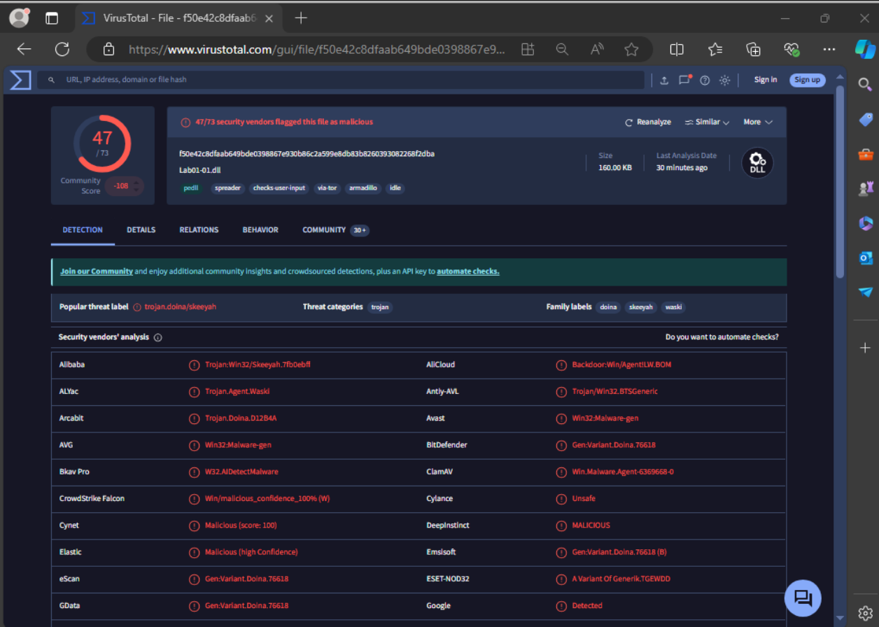

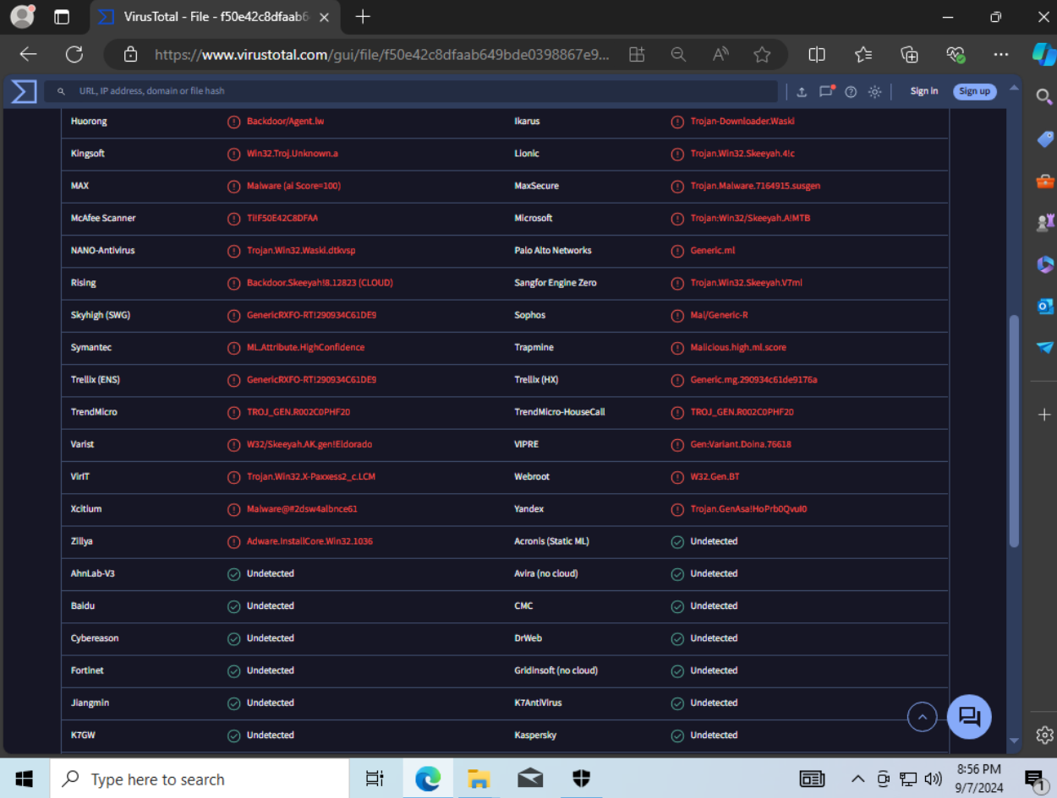

#### Details

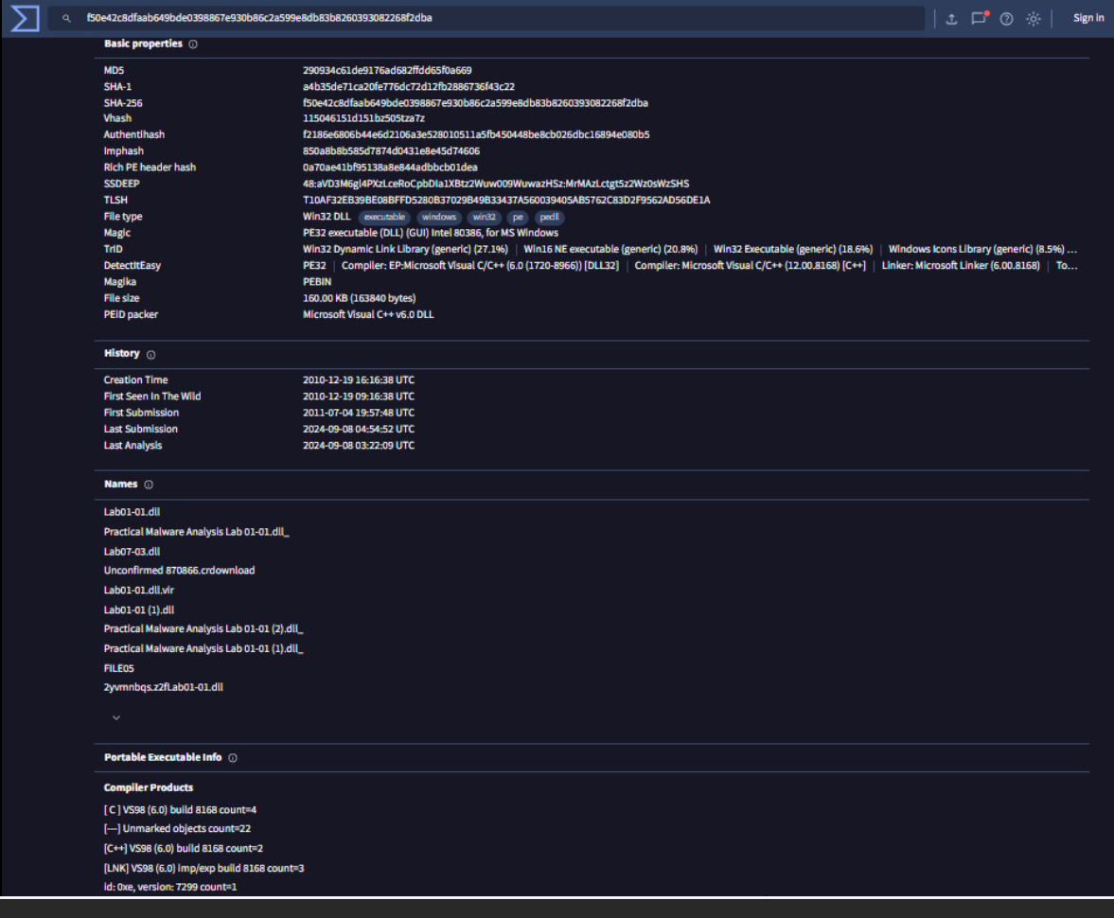

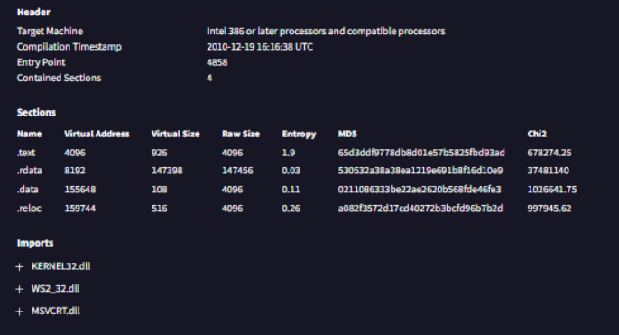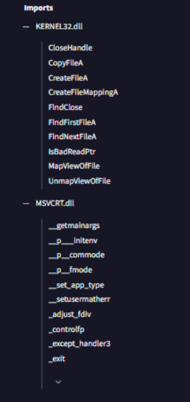

#### Relations

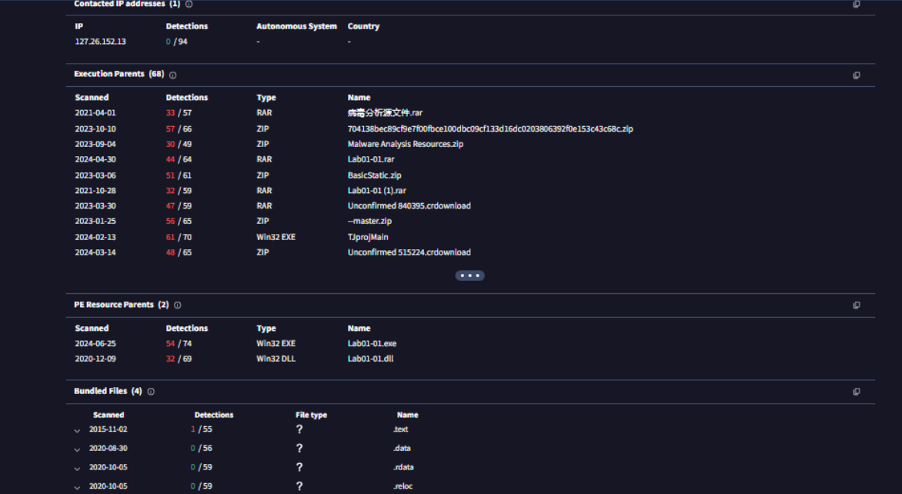

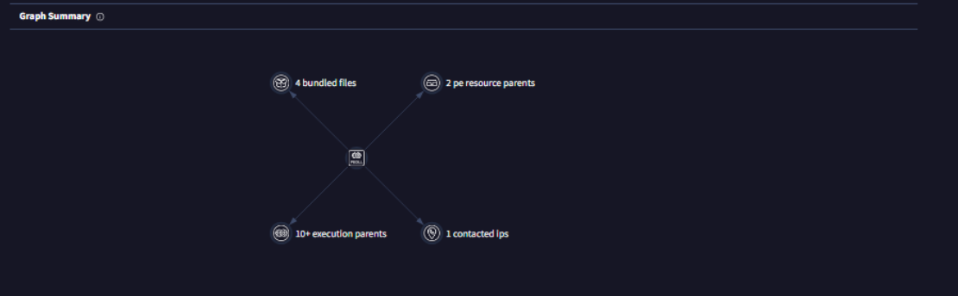

#### Behavior

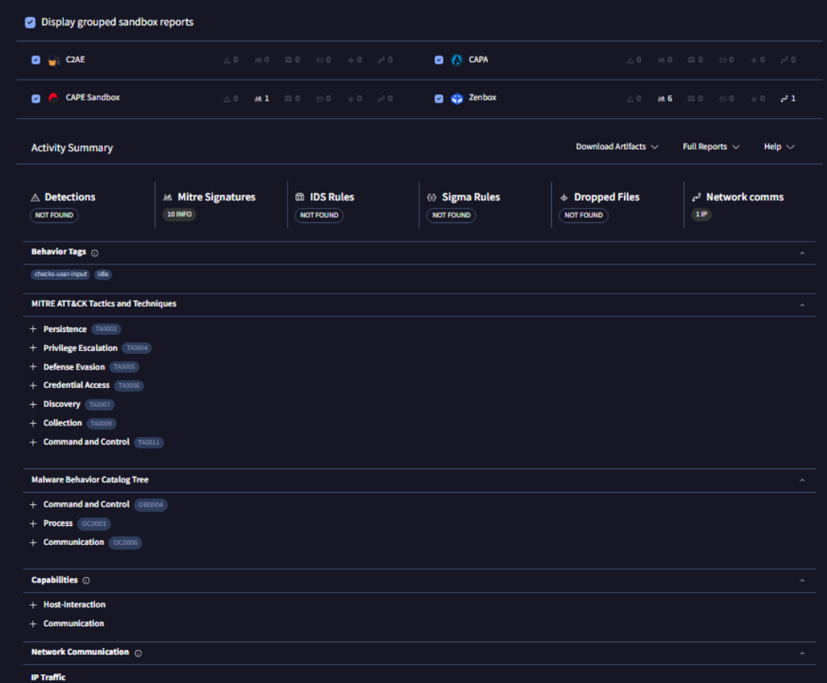

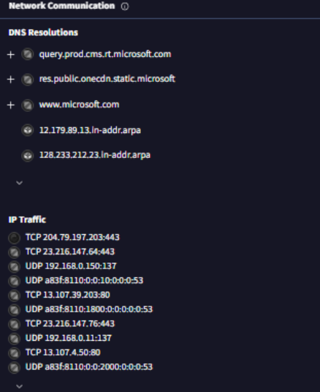

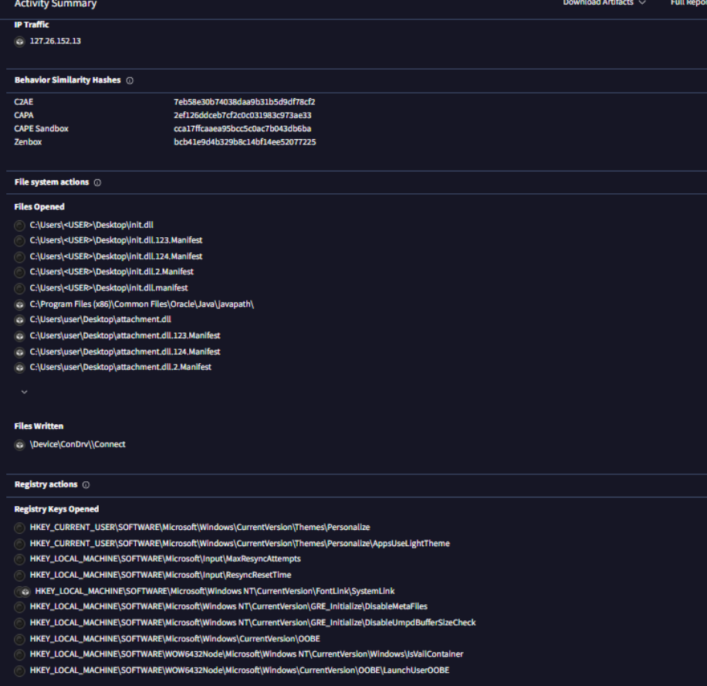

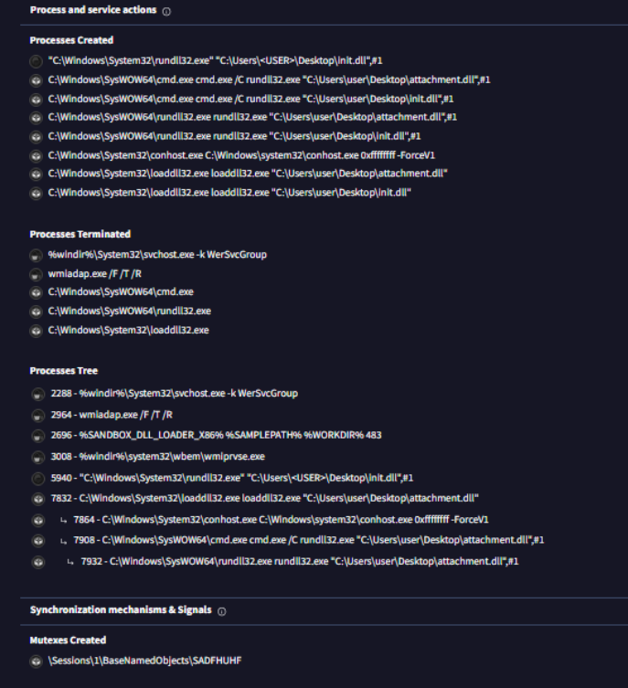

## Lab01-02.exe

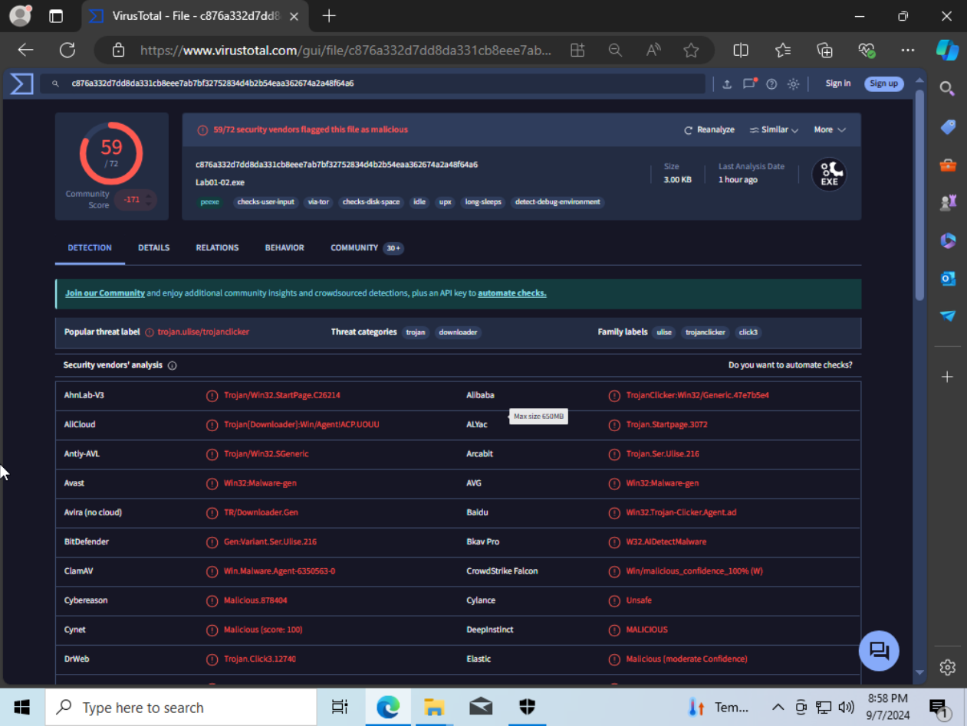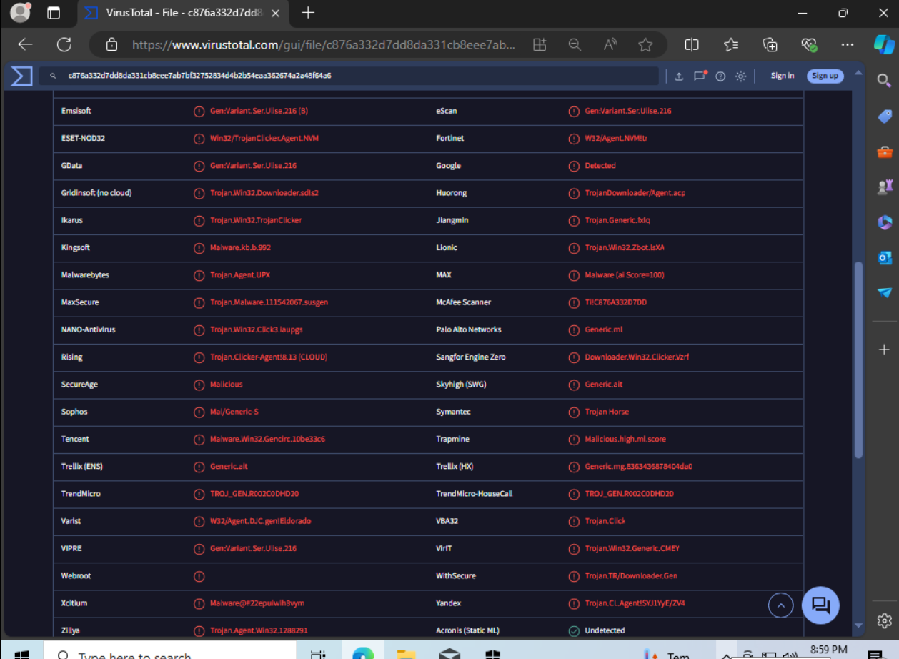

#### Details

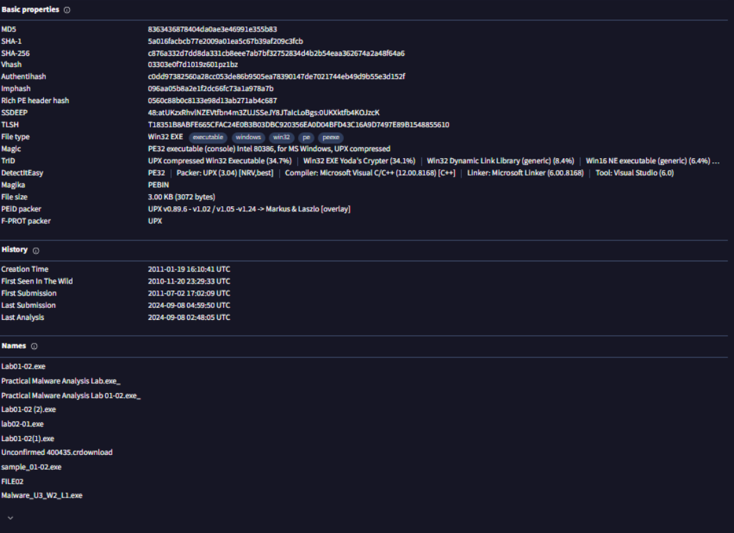

*\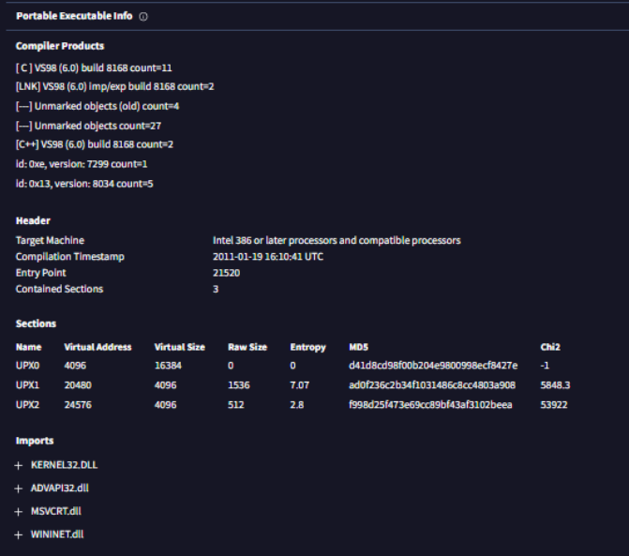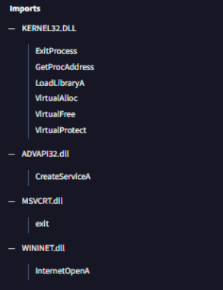*

#### Relations

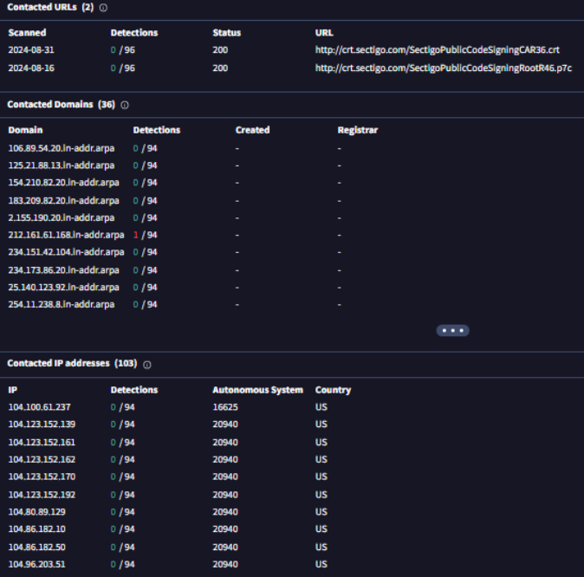

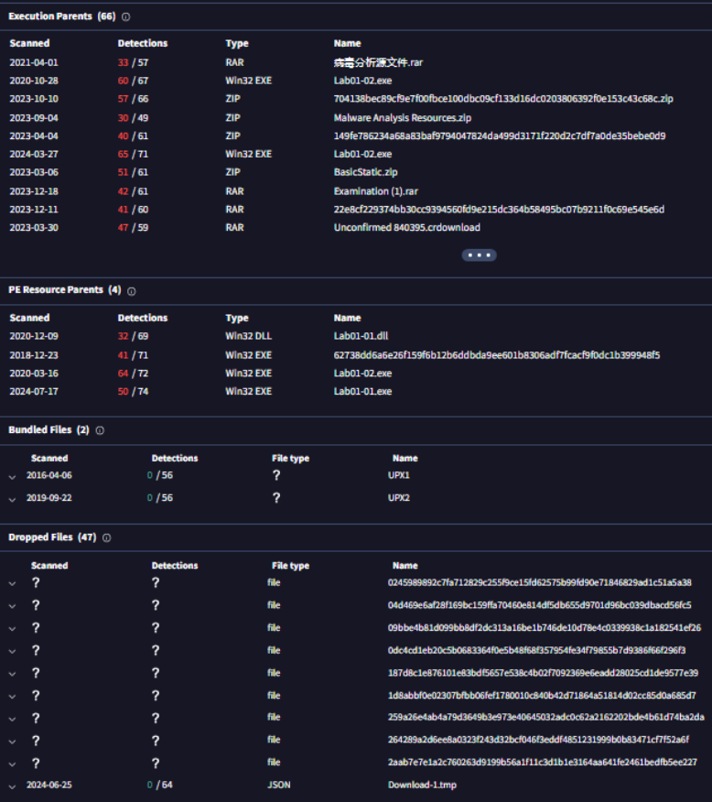

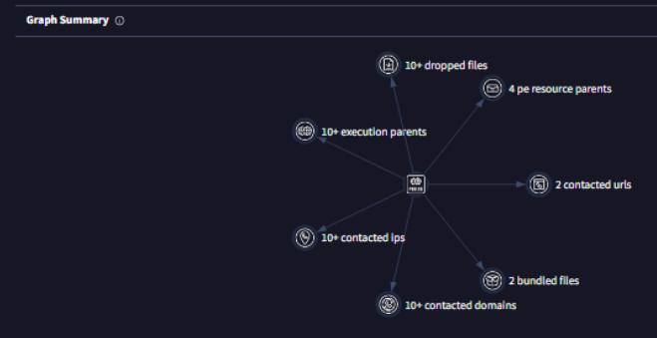

#### Behavior

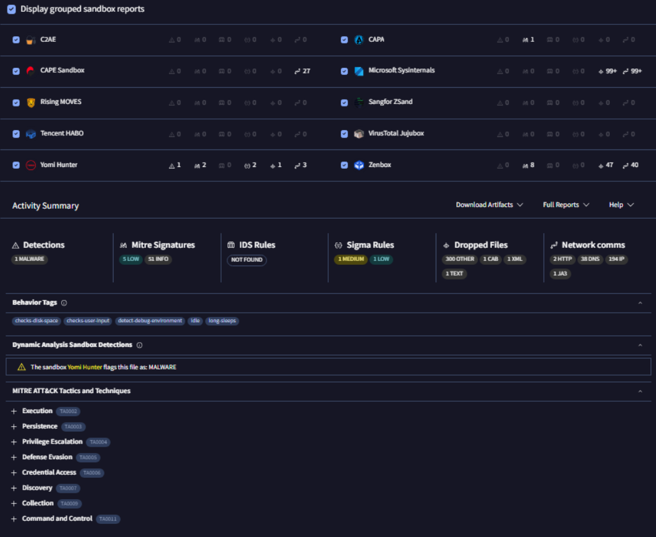

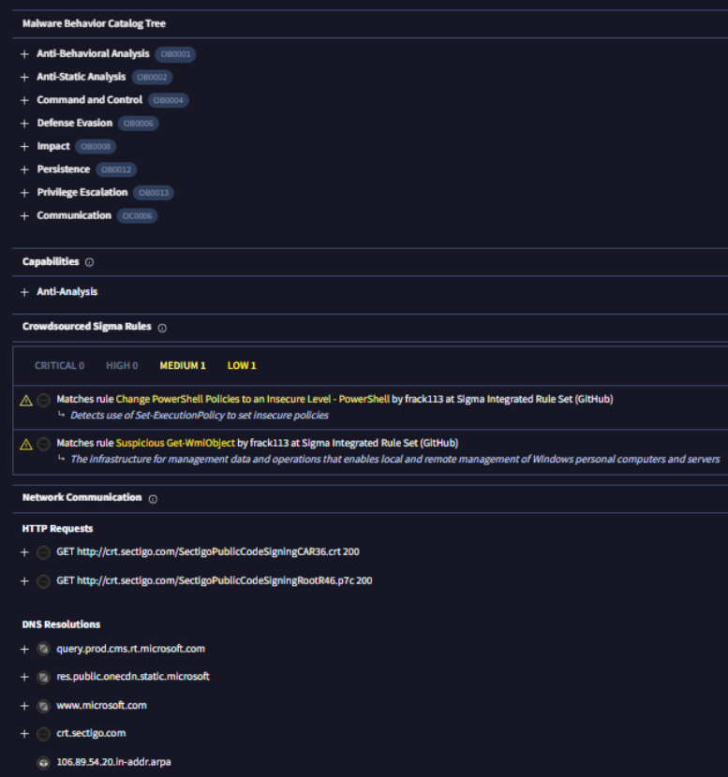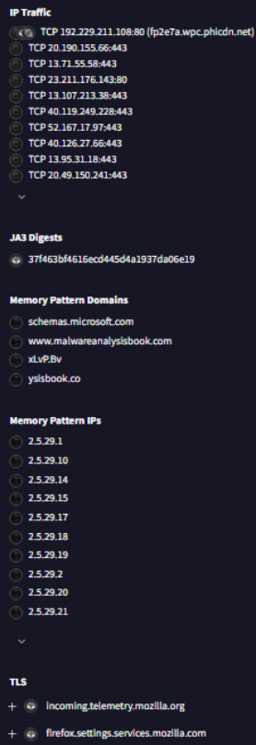

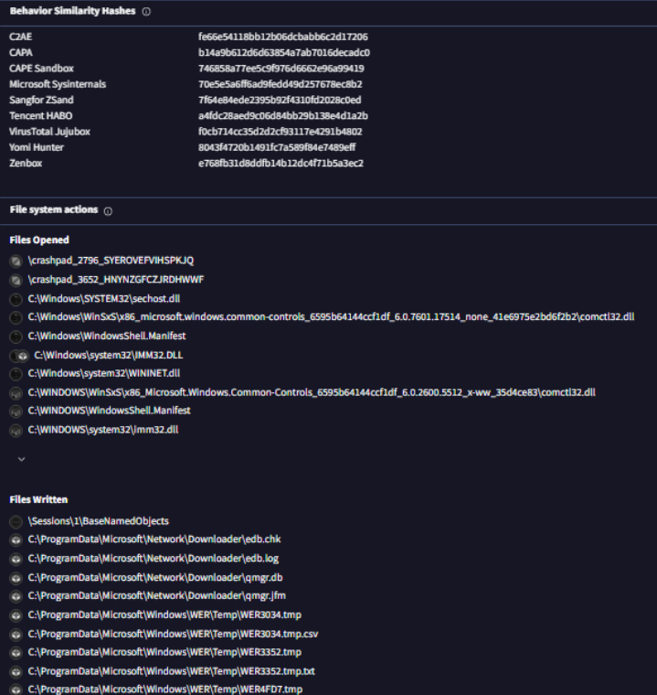

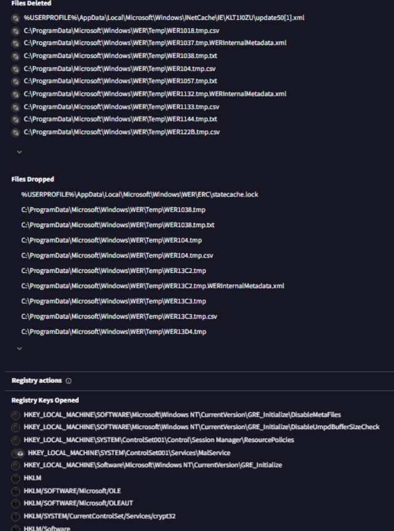

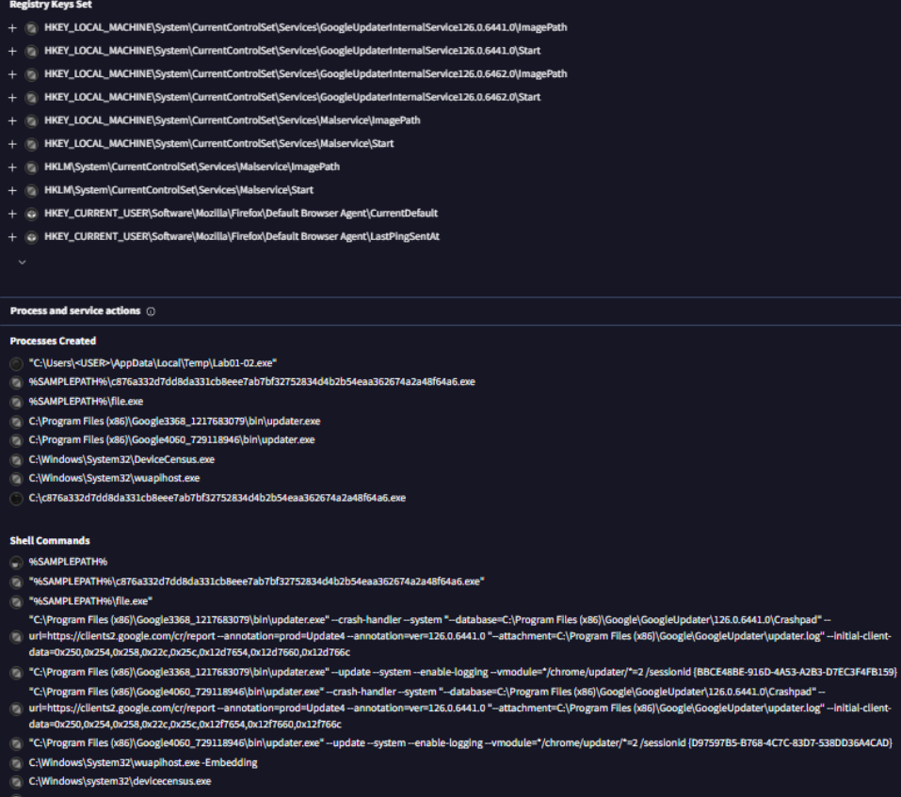

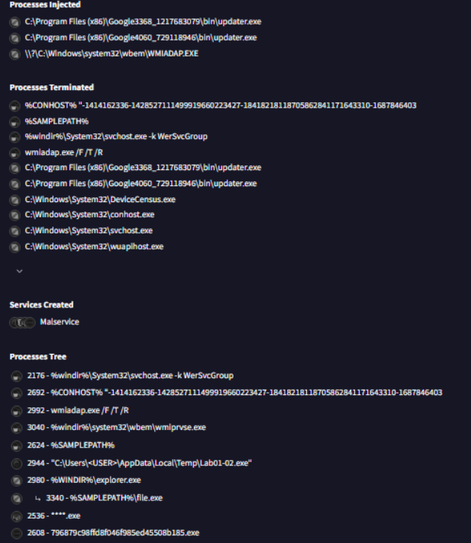

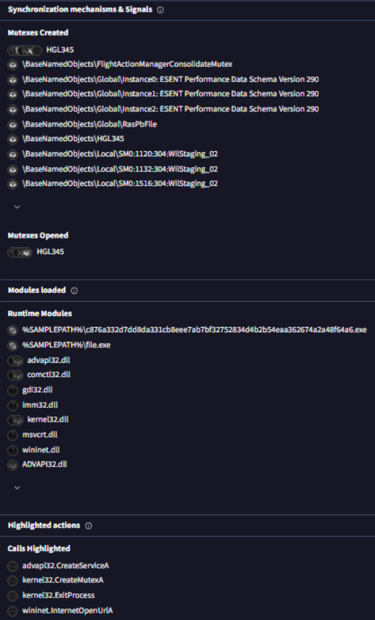

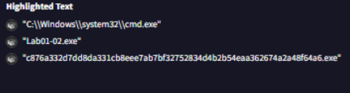

## Lab01-03.exe

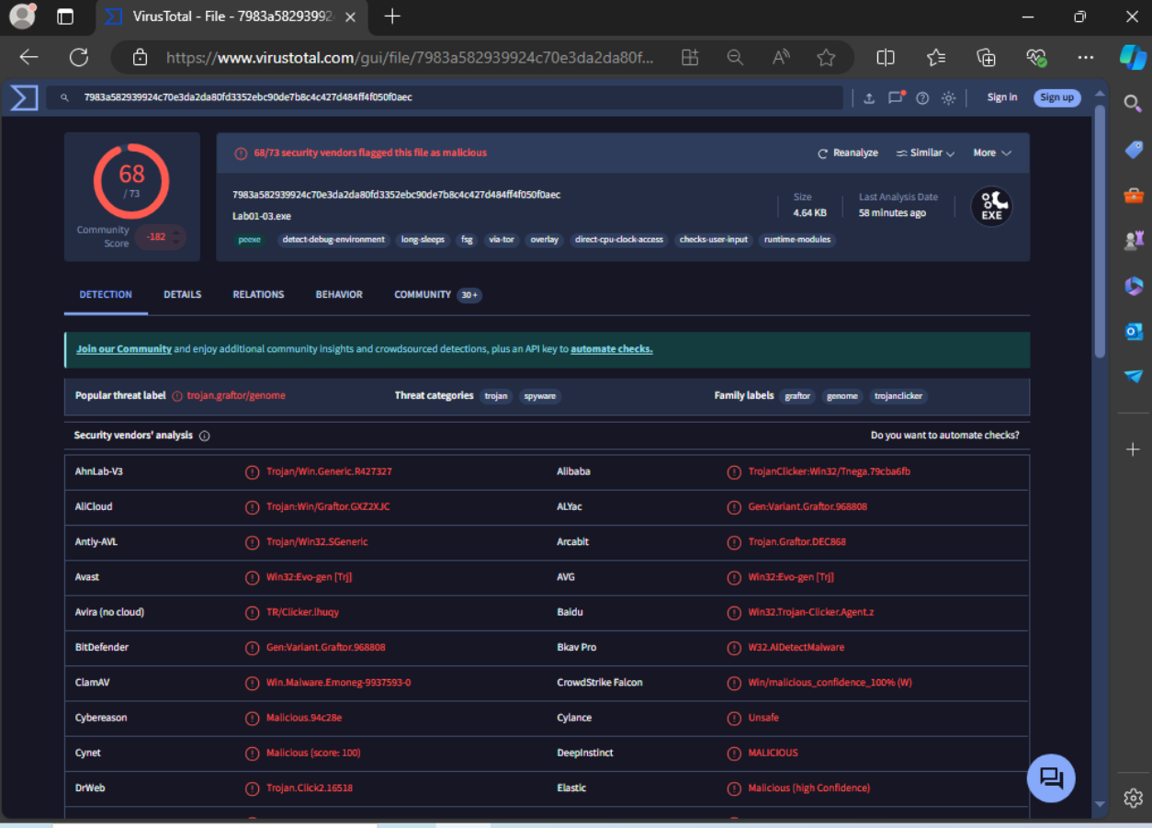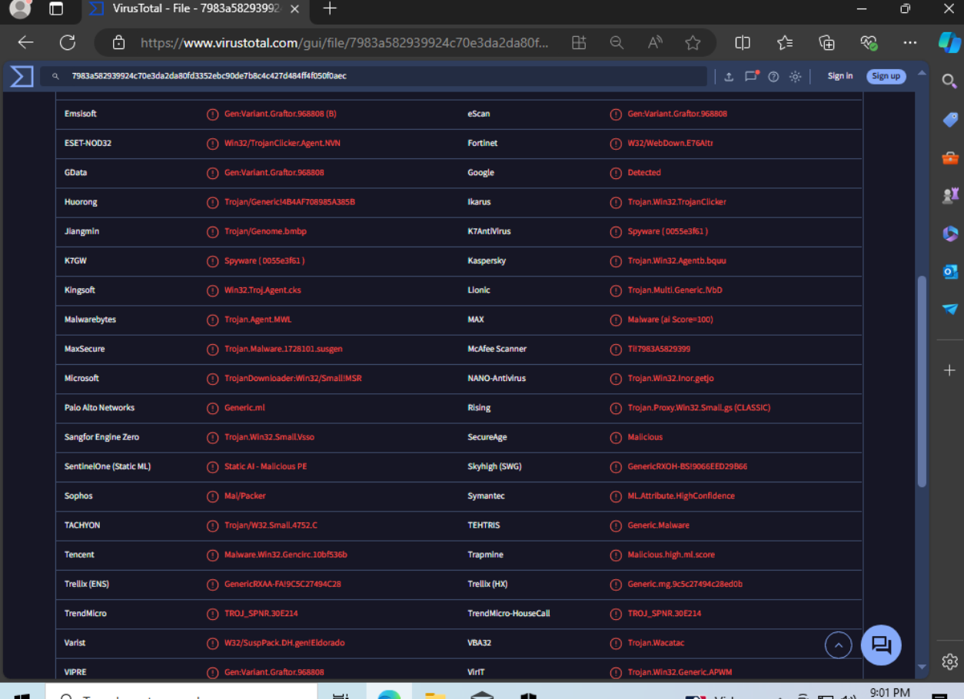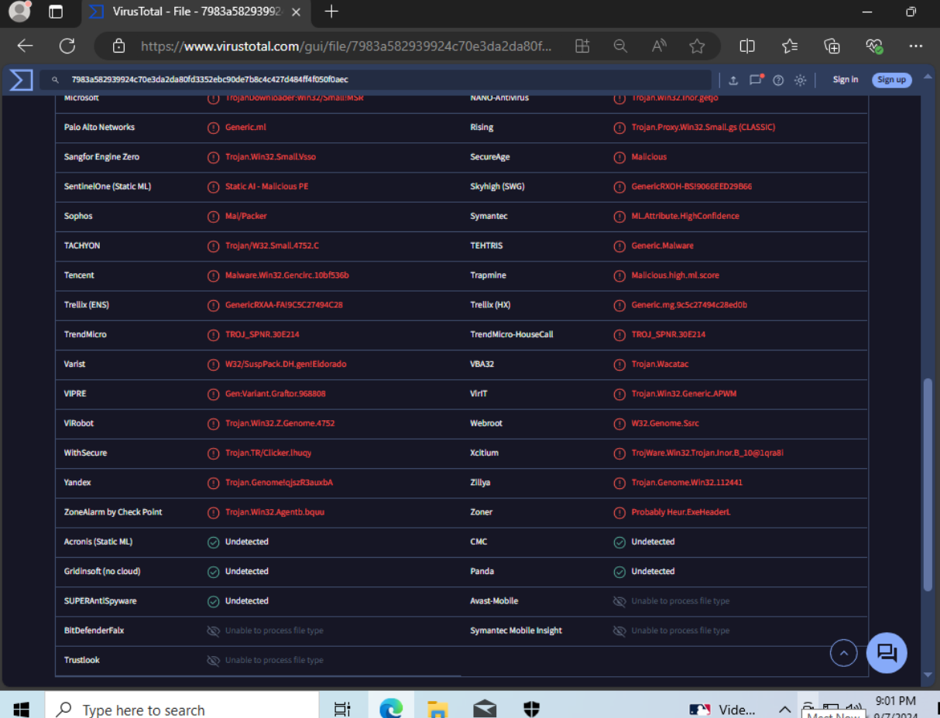

#### Details

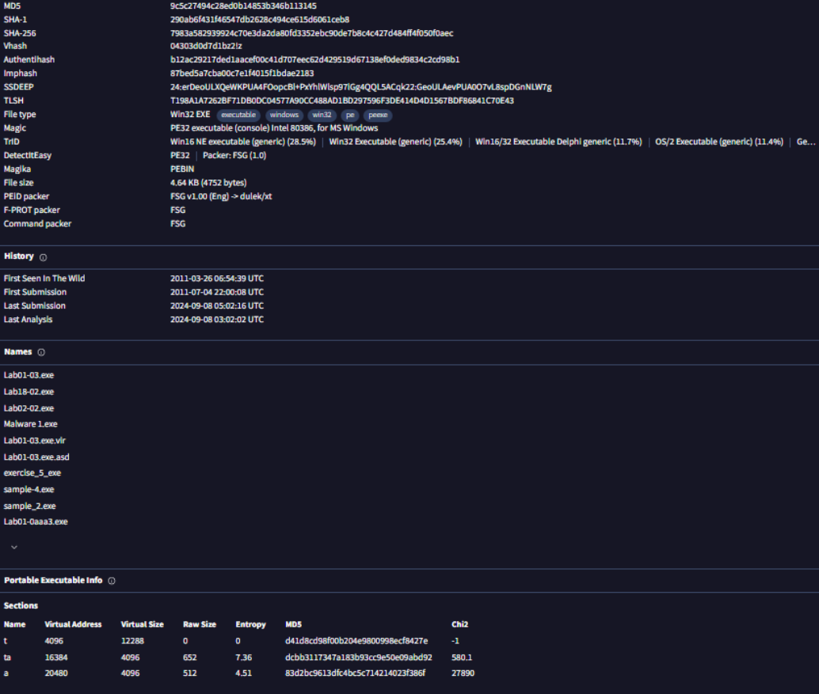

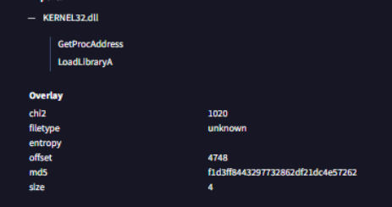

#### Relations

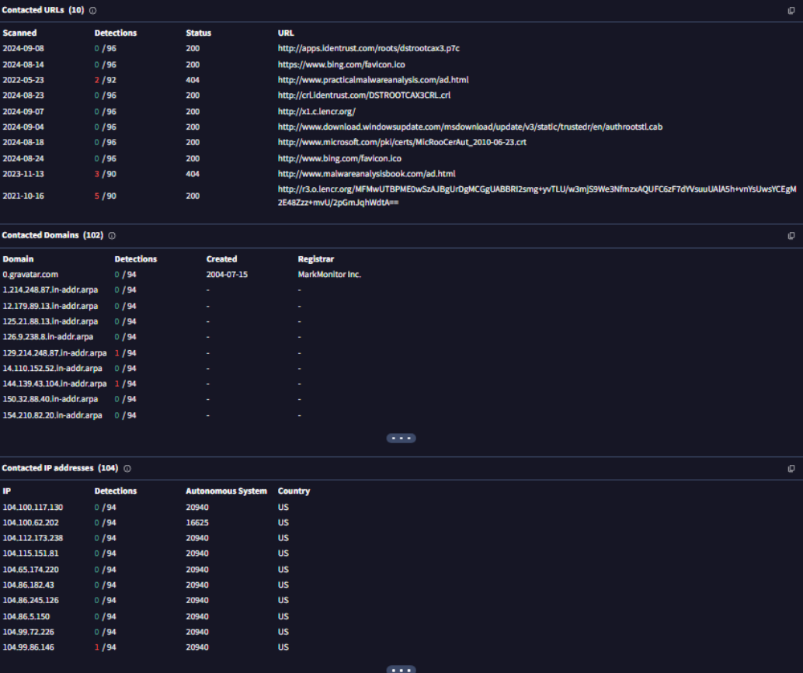

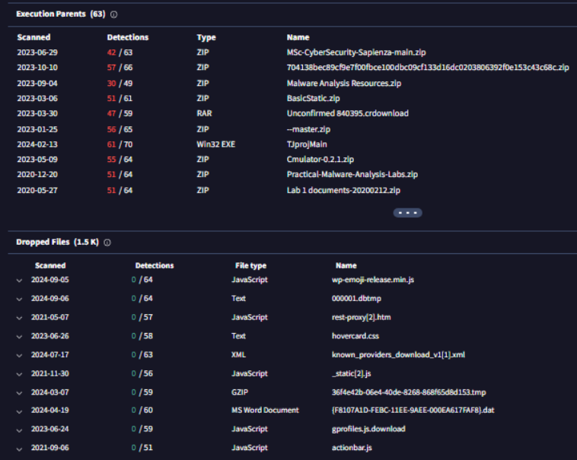

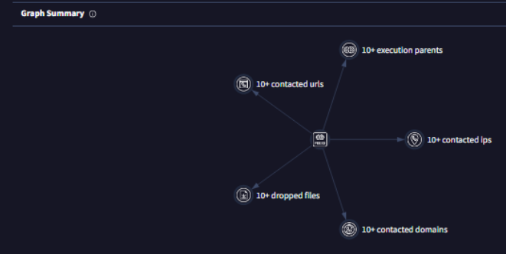

#### Behavior

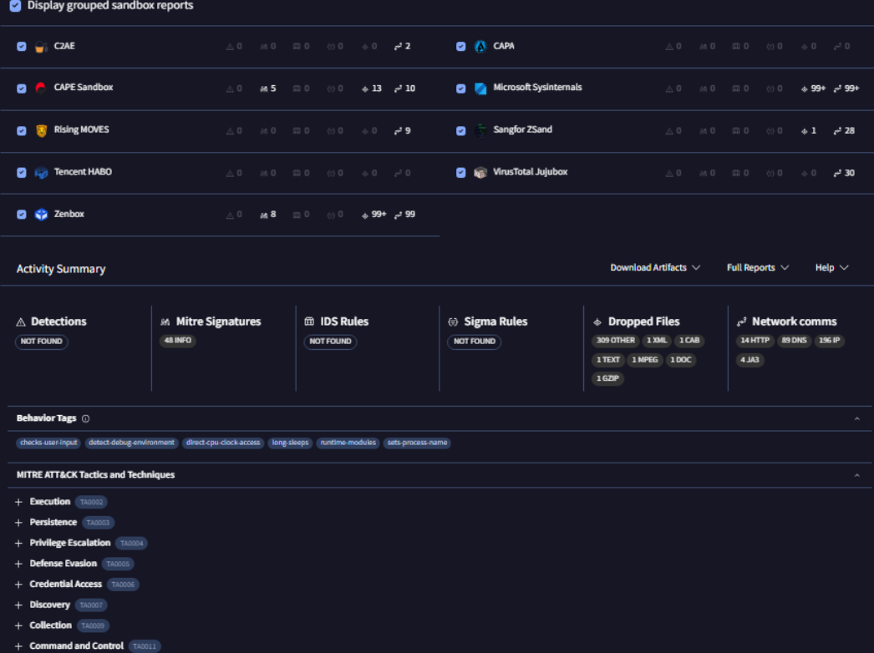

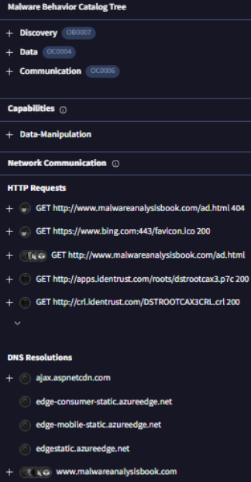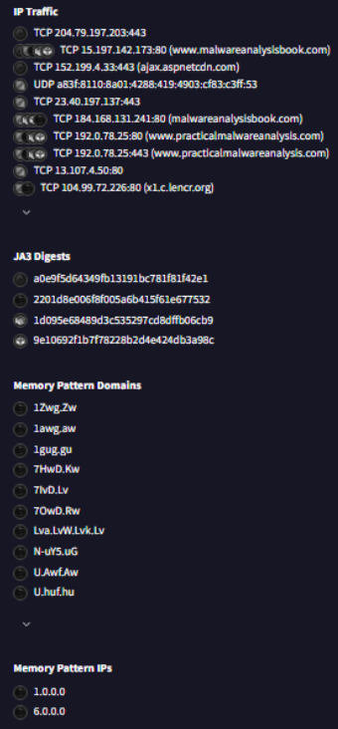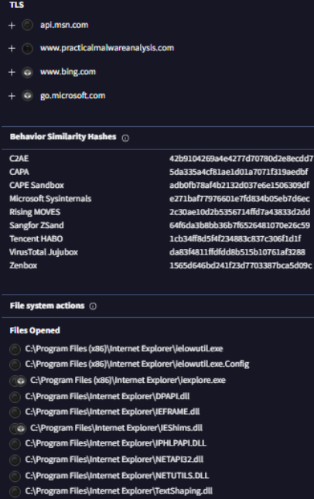

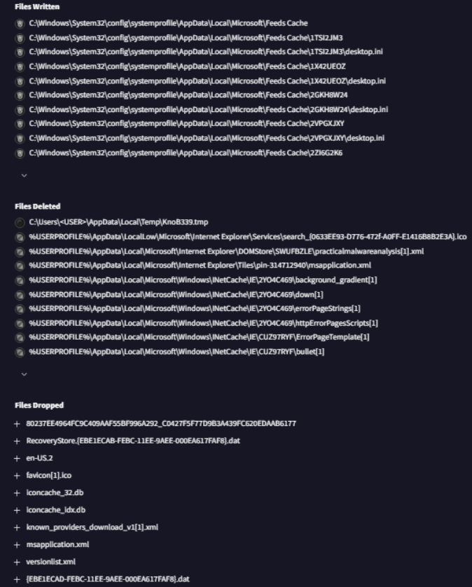

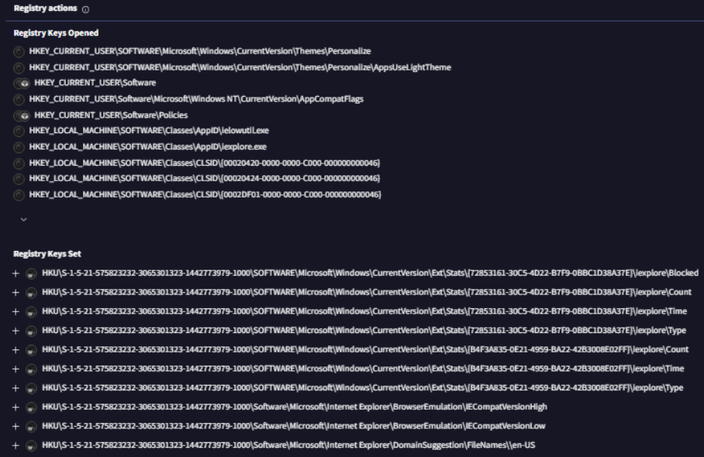

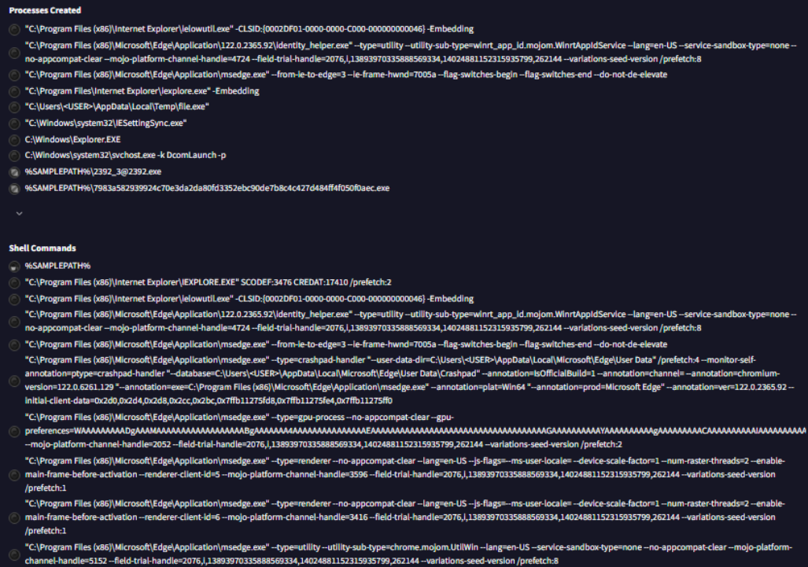

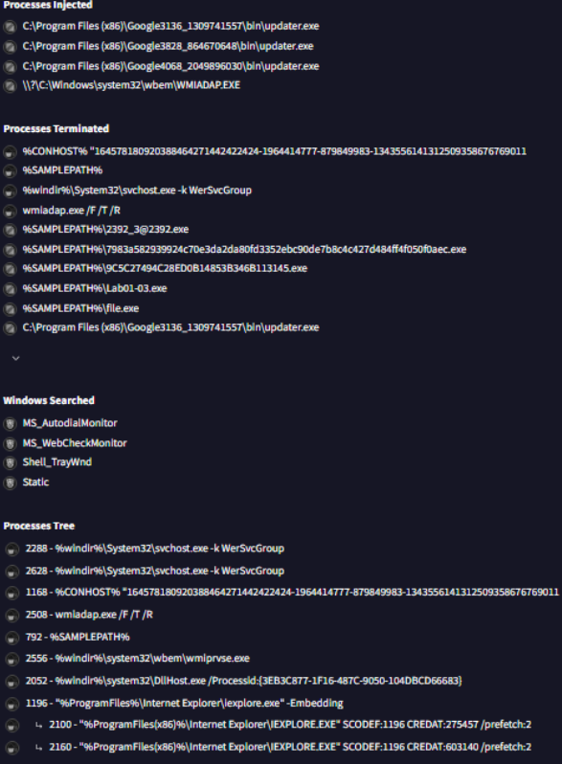

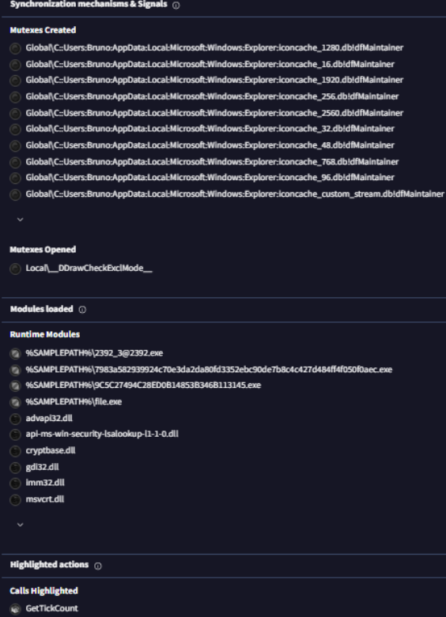

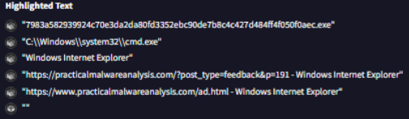

## Lab01-04.exe.

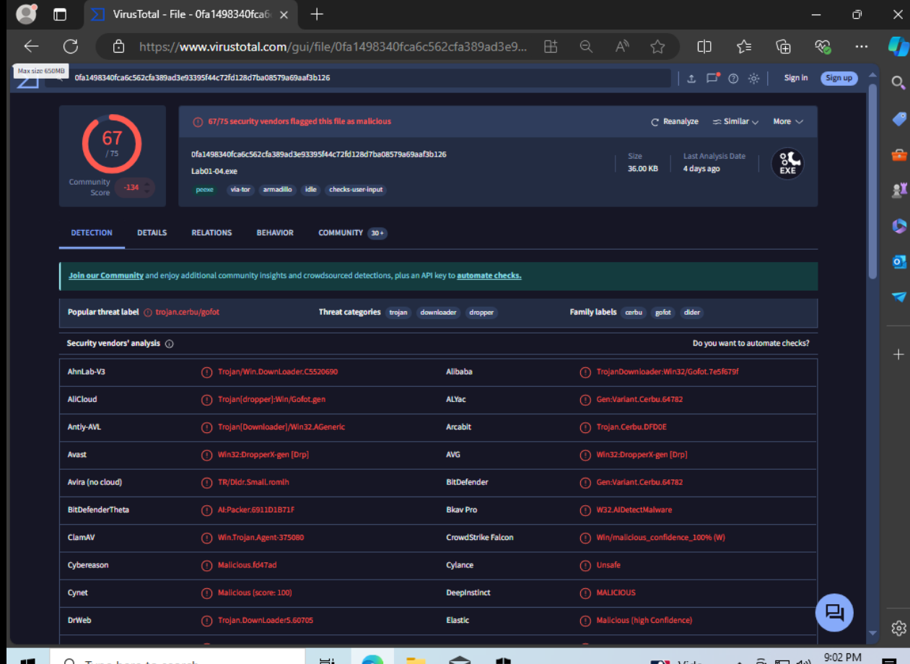

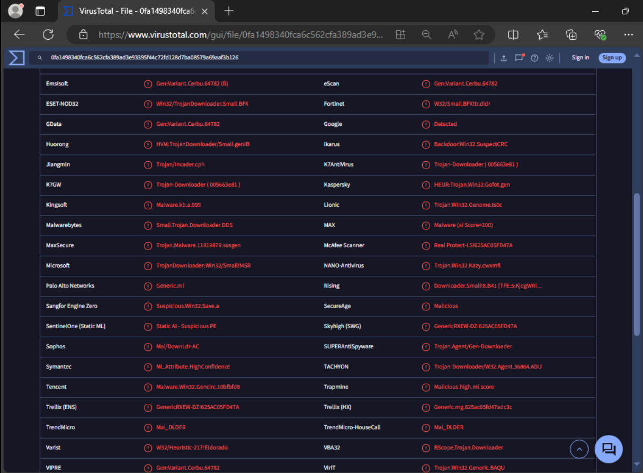

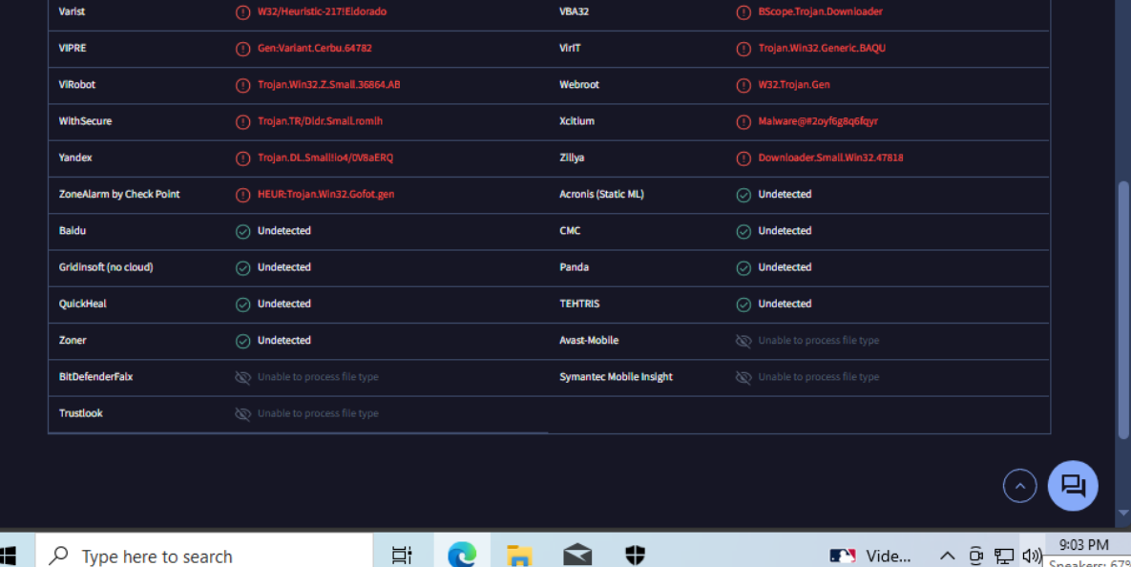

#### Details-

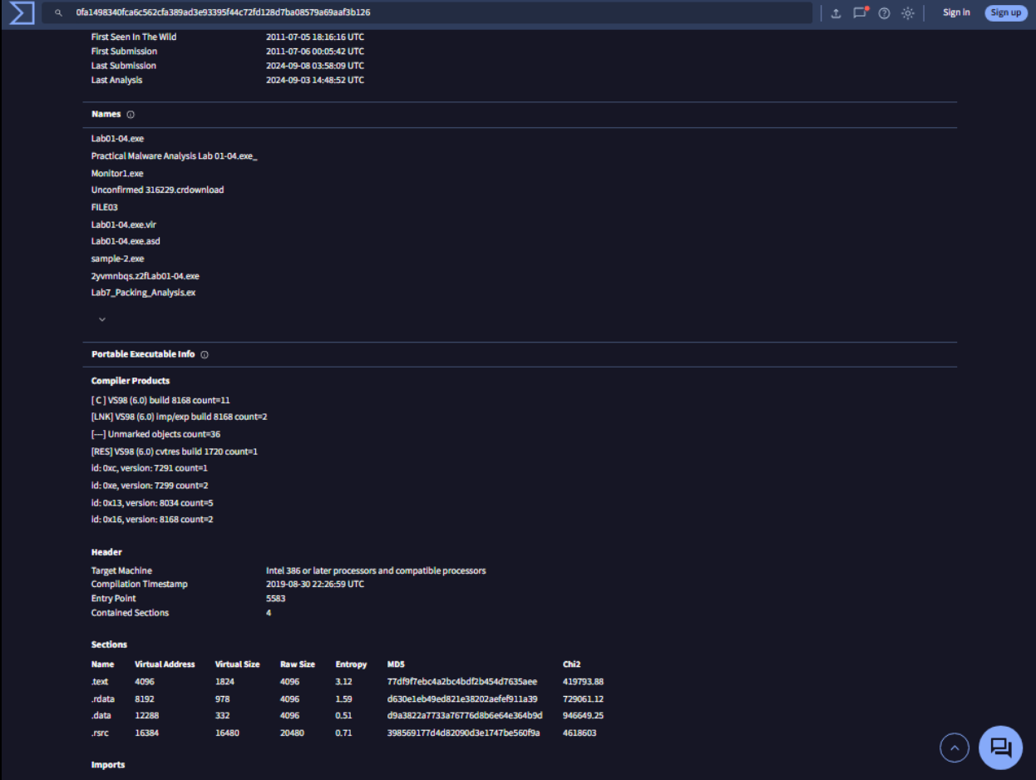

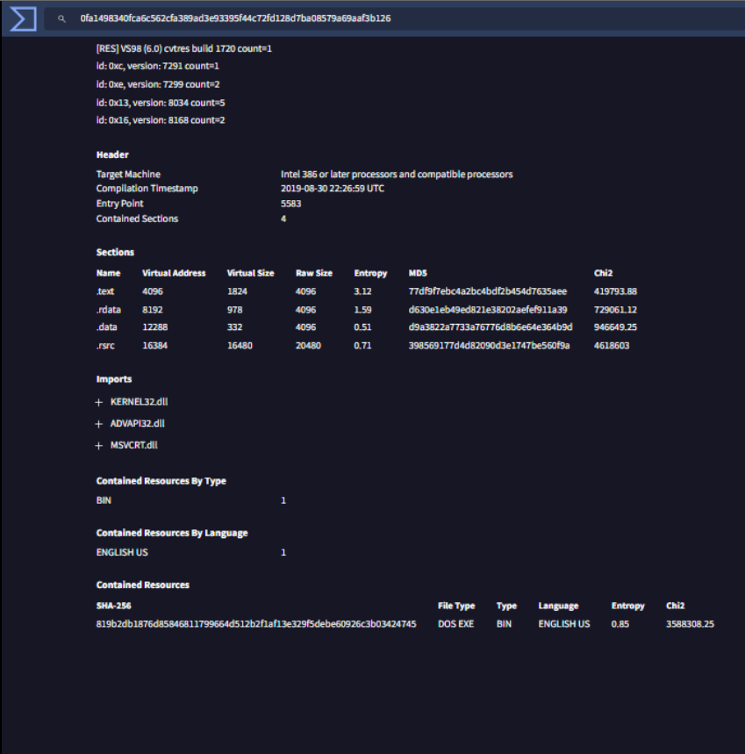

#### Relations

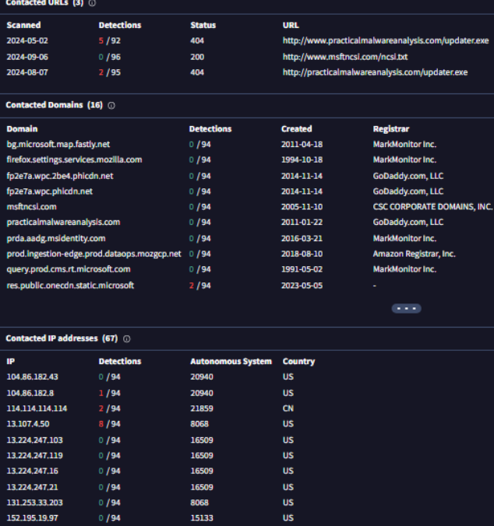

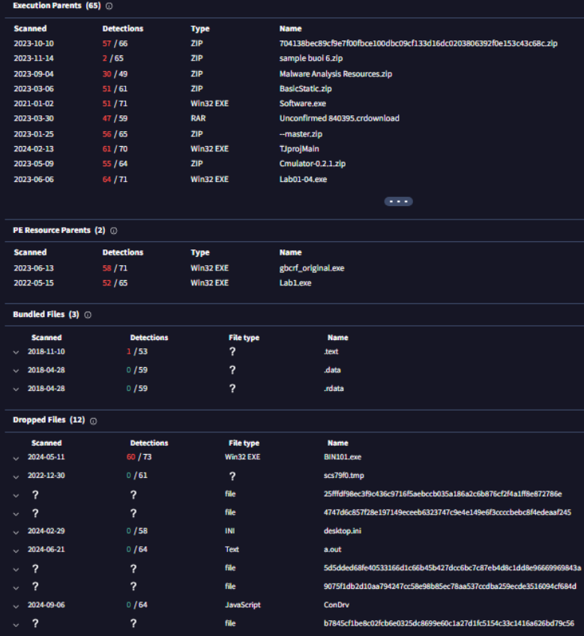

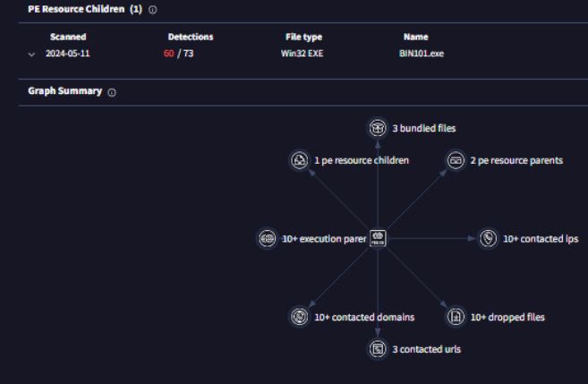

#### Behavior

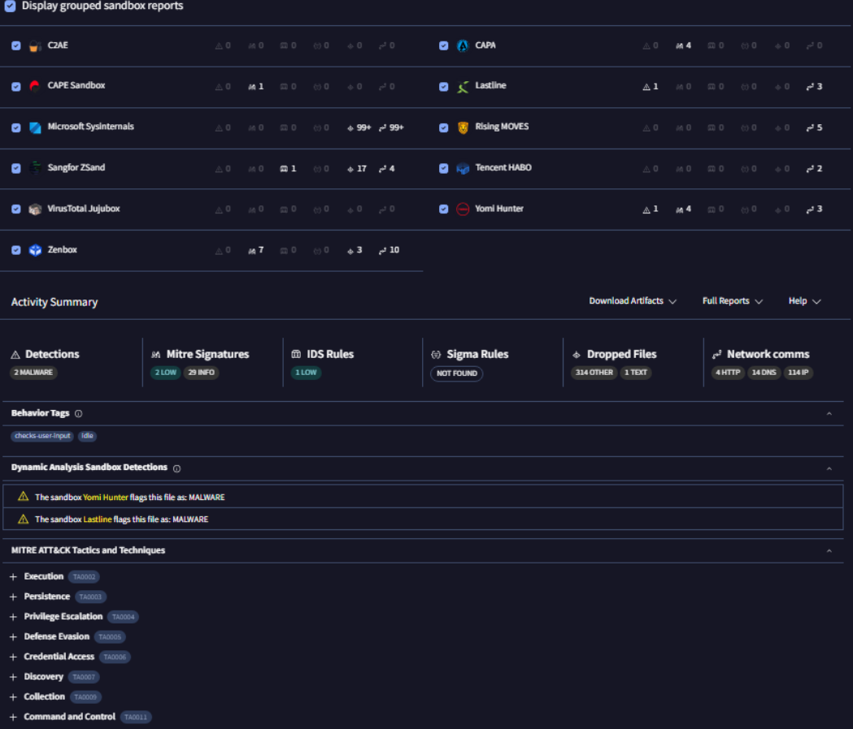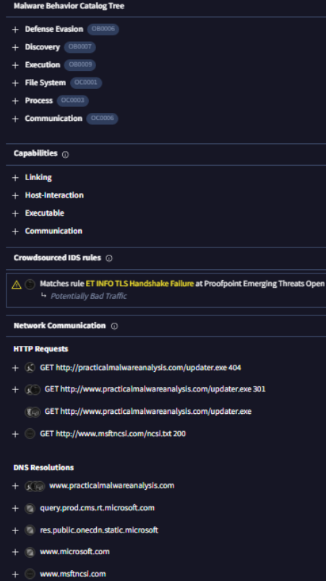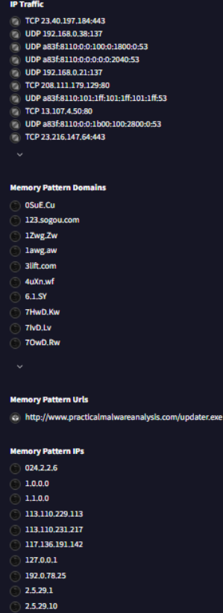

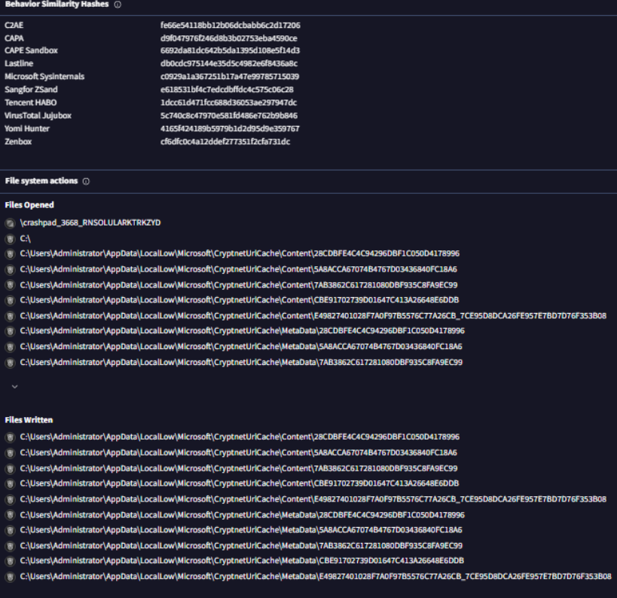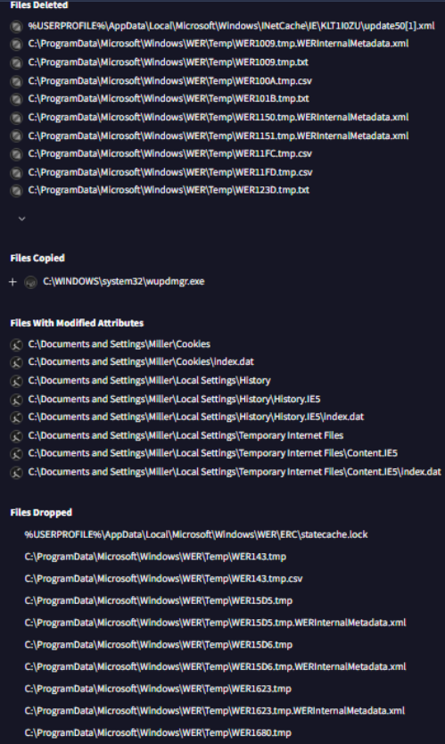

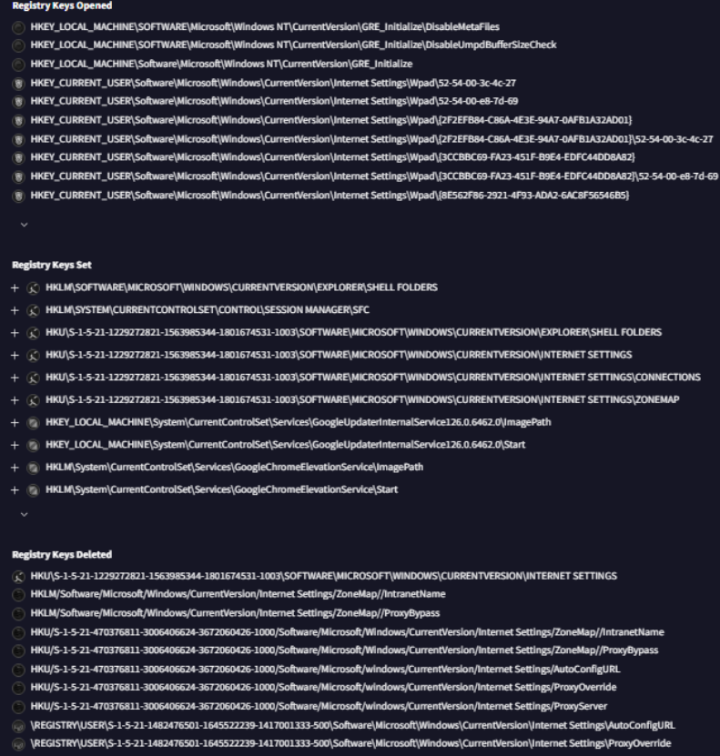

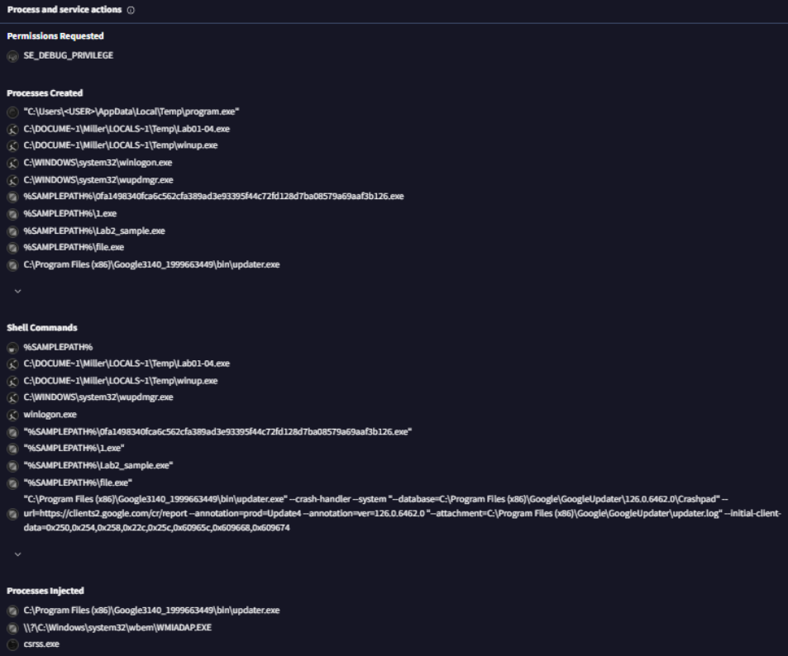

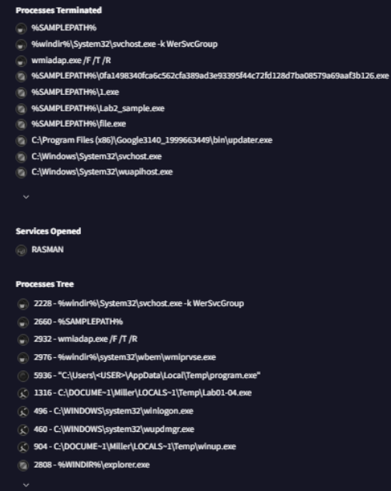

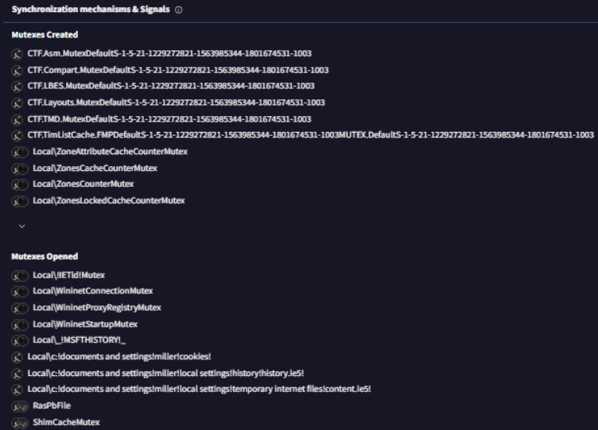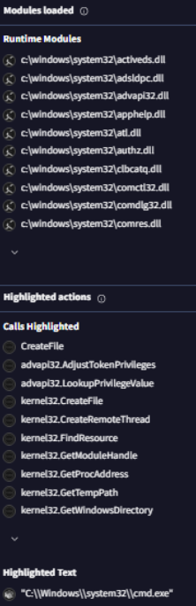

# ***Resources***

Aikido Security. (n.d.). *Static Code Analysis (SAST) - Aikido Security*. https://www.aikido.dev/scanners/static-code-analysis-sast?utm_source=expertinsights&utm_medium=referral&utm_campaign=sast-solution

Eng, A. A. (2023, June 30). Comparing static and Dynamic Malware Analysis: Unveiling the secrets of cyber threats. *Medium*. https://medium.com/@aa.adnane/comparing-static-and-dynamic-malware-analysis-unveiling-the-secrets-of-cyber-threats-f6be509b223f#:~:text=Despite%20its%20strengths%2C%20static%20analysis,files%20on%20an%20infected%20system.

Karl-Bridge-Microsoft. (2023, February 9). *LoadLibraryA function (libloaderapi.h) - Win32 apps*. Microsoft Learn. <https://learn.microsoft.com/en-us/windows/win32/api/libloaderapi/nf-libloaderapi-loadlibrarya>

Sikorski, M., & Honig, A. (2012). Practical malware analysis : A hands-on guide to dissecting malicious software. No Starch Press, Incorporated.

Team, S. T. (2023, July 21). *Top 8 malware analysis tools*. Security Tools. https://www.security-tools.com/top-malware-analysis-tools/

Witts, J. (2024, July 4). *The Top 8 static code analysis Solutions*. Expert Insights. https://expertinsights.com/insights/the-top-static-code-analysis-solutions/